09.08.22
Dear client,
Good day,
Here below Turkon announcement about about Heavy Weight Surcharge (HWSC) - REVISED:
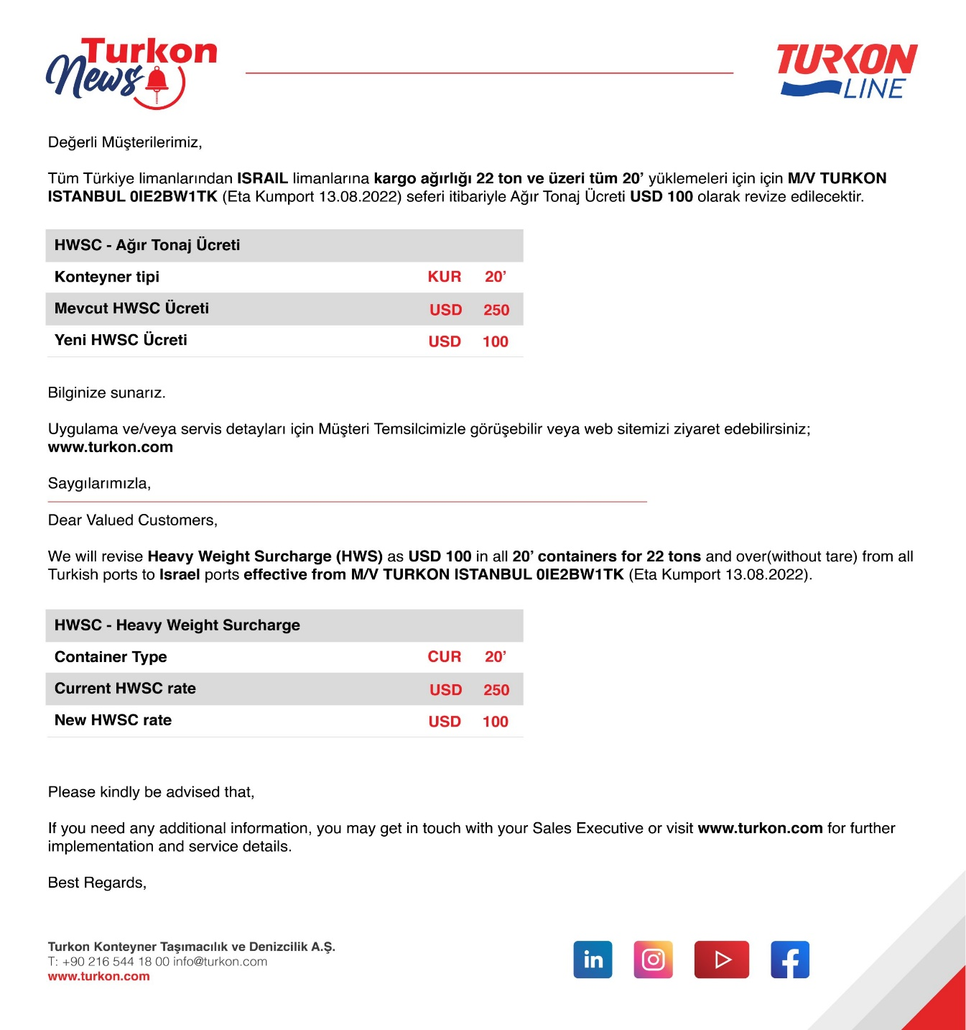

Tiran shipping (1997) Ltd,
As Turkon agent

