09.08.22
Dear client,
Good day,
Here below Turkon announcement about ERS (Equipment Repositioning Surcharge) - Cancelled:

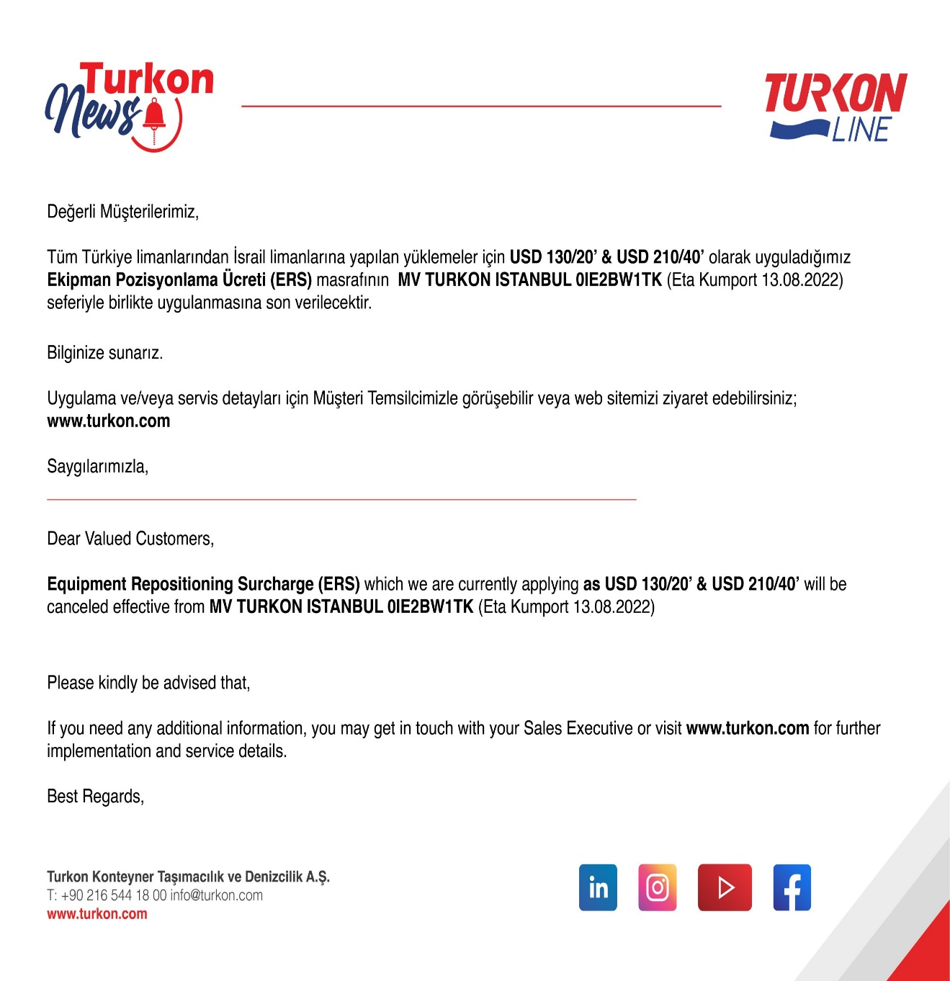

Tiran shipping (1997) Ltd,
As Turkon agent

